

NATIONAL UNIVERSITY OF TECHNOLOGY
(Department of Computer Science)
CS161– Database Systems
Instructor: Miss Faiza khan
Name: Bisma Fatima
Roll no: f24605036

LAB TASK 10

In Lab Tasks
Database Structure Overview
∙ Books(BookID, Title, Author, ISBN, Price, StockQuantity)
∙ Customers(CustomerID, Name, Email, Address)
∙ Orders(OrderID, CustomerID, OrderDate, TotalAmount)
∙ OrderItems(OrderItemID, OrderID, BookID, Quantity, Price)
Task 1: Aggregate Functions
Use aggregate functions to analyze the bookstore’s performance:
- Calculate the average, maximum, and minimum price of all books from the Books table.
EXPLANATION:
Average, Max, and Min Book Price: Calculates key price metrics for all books.

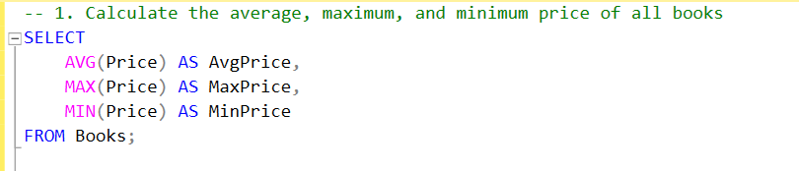
OUTPUT
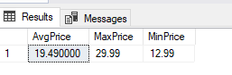
- Find the maximum and minimum quantity ordered from the OrderItems table.

EXPLANATION:
Max and Min Quantity Ordered: Finds the highest and lowest quantity ordered for any book.

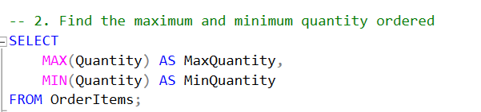
OUTPUT
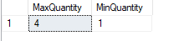
- Determine the total stock quantity available across all books in the Books table.

EXPLANATION:
Total Stock Quantity: Calculates the total stock available across all books.

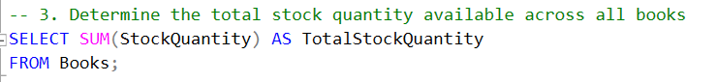
OUTPUT
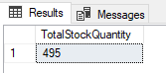

- Count the total number of orders placed (rows in Orders table).

EXPLANATION:
Total Number of Orders: Counts the total number of orders placed.

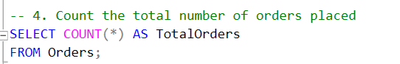
OUTPUT
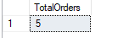
- Calculate the total revenue generated from all orders using the TotalAmount field in the Orders table.

EXPLANATION:
Total Revenue: Calculates the total revenue generated from all orders.

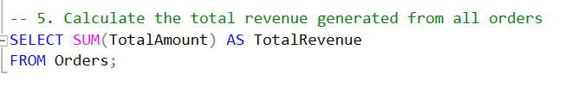
OUTPUT
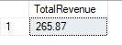
Task 2: Sorting Data with ORDER BY Clause
Sort and organize the bookstore data:
- List all book titles and sort them in descending order by price.

EXPLANATION:
Book Titles by Price (Descending): Lists books by price from highest to lowest.
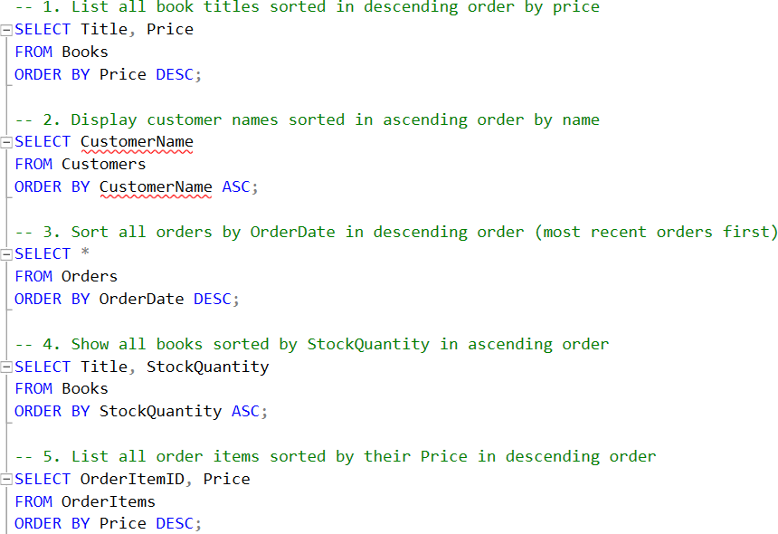
OUTPUT
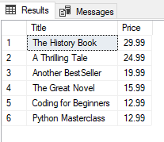
- Display customer names and sort them in ascending order by name.

EXPLANATION:
Customer Names (Ascending): Lists customers in alphabetical order.

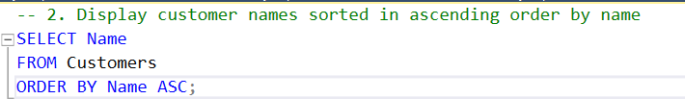
OUTPUT
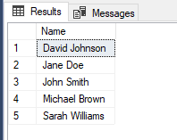
- Sort all orders by OrderDate in descending order to show most recent orders first.

EXPLANATION:
Orders by Date (Descending): Shows the most recent orders first.


OUTPUT
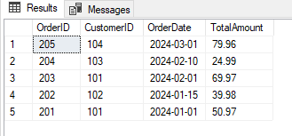
- Show all books sorted by StockQuantity in ascending order.

EXPLANATION:
Books by Stock Quantity (Ascending): Lists books with the lowest stock first.


OUTPUT

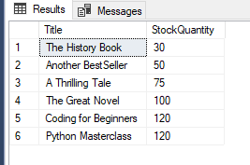
- List all order items sorted by their Price in descending order.

EXPLANATION:
Order Items by Price (Descending): Lists order items by price from highest to lowest.


OUTPUT
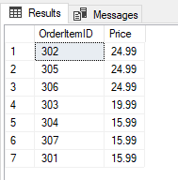
Task 3: Grouping, Filtering, and Advanced Aggregate Queries
Write advanced queries using GROUP BY and HAVING:
- For each book, calculate the total revenue (Price × Quantity) from the OrderItems table. Show only books with total revenue greater than $50. Group by BookID.

EXPLANATION:
Total Revenue per Book: Calculates revenue for each book and filters for books with revenue > $50.
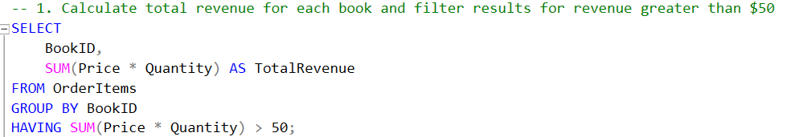
OUTPUT
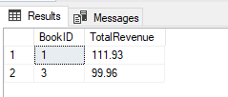
- For each order:
  - Calculate total price (Price × Quantity)
  - Calculate total quantity
  - Count the number of unique books
  - Count the total number of order items
Group the results by OrderID and sort them in ascending order by OrderID.

EXPLANATION:
Order Details: Calculates total price, quantity, unique books, and total items for each order.
Order Summary: Groups order details by OrderID and sorts them.

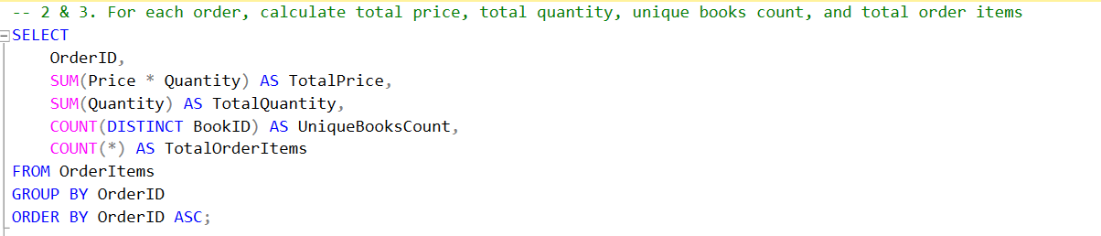
OUTPUT
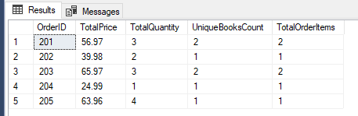
- Count the number of orders placed by each customer. Group the result by CustomerID.

EXPLANATION:
Orders per Customer: Counts the number of orders placed by each customer.
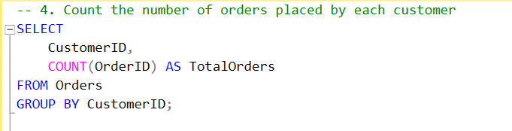
OUTPUT
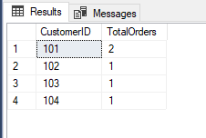
- Calculate the average number of books ordered per order using the OrderItems table (group by OrderID).

EXPLANATION:
Average Books per Order: Calculates the average number of books ordered per order.

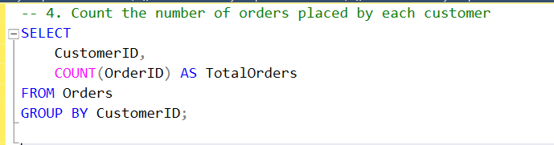
OUTPUT
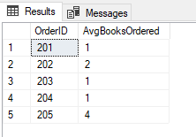
Task 4: Joins
Perform different types of joins to connect related data:
- Retrieve customer names and their order dates using an INNER JOIN on Customers and Orders.

EXPLANATION:
Customer Orders: Retrieves customer names and order dates.
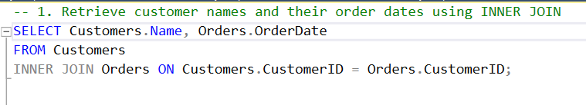
OUTPUT
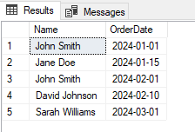
- List all books and the number of times they’ve been ordered, using a LEFT JOIN from Books to OrderItems.

EXPLANATION:
Book Order Frequency: Lists books and the number of times they've been ordered.

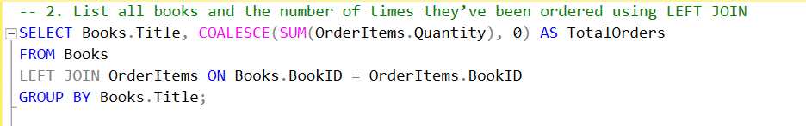
OUTPUT
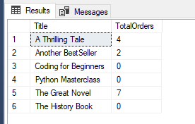
- Display all orders and the book titles included, using INNER JOINs across Orders, OrderItems, and Books.

EXPLANATION:
Order Details with Book Titles: Displays orders with book titles.

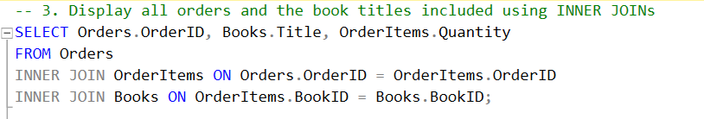
OUTPUT
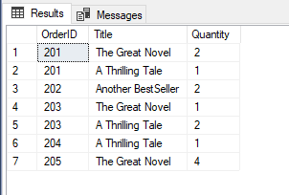

- Show all customers and their orders, including customers who haven’t placed any orders yet using a LEFT JOIN.

EXPLANATION:
Customers with Orders: Shows all customers and their orders, including those without orders.

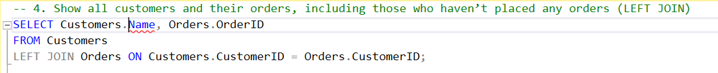
OUTPUT
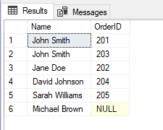
- Join OrderItems and Books to display each ordered book's title, quantity, and order price.

EXPLANATION:
Ordered Books: Displays ordered book titles, quantities, and prices.

OUTPUT
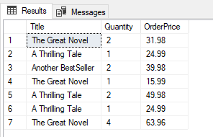
Task 5: Subqueries
Use subqueries to solve complex business questions:
- Retrieve the titles of books whose price is above the average book price.

EXPLANATION:
Books Above Average Price: Retrieves titles of books priced above the average.
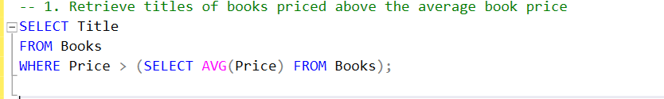
OUTPUT

- Find the customer(s) who have spent the most in total (based on the TotalAmount in the Orders table).

EXPLANATION:
Top-Spending Customer: Finds the customer who spent the most.

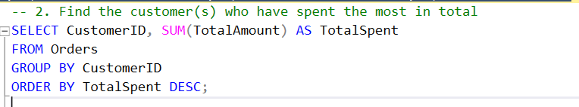
OUTPUT
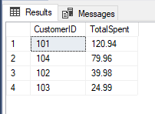
- List customers who placed orders in the last 30 days.

EXPLANATION:
Recent Customers: Lists customers who placed orders in the last 30 days.

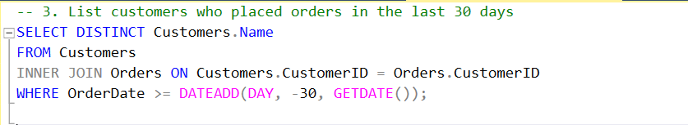
OUTPUT
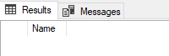

- Find books that were never ordered (i.e., not present in OrderItems).

EXPLANATION:
Unordered Books: Finds books that were never ordered.
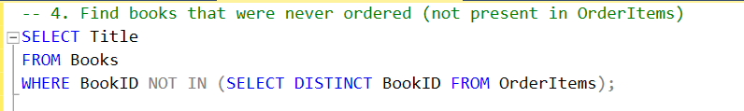
OUTPUT

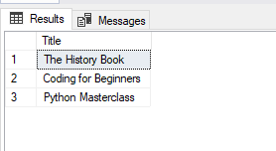

- Display books whose price is greater than ALL prices of books written by a specific author (e.g., 'J.K. Rowling').

EXPLANATION:
Books Priced Higher than Author's: Displays books priced higher than all books by a specific author

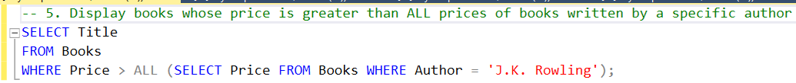
OUTPUT
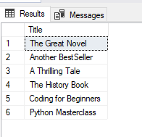

Post Lab Tasks
Task 1
Report Generation:
Write a report that includes:
- The SQL queries written for the In-Lab tasks.
- The output of each query (screenshots from your SQL database management system).
- A brief explanation of each query and its purpose.
Lifelong Learning Component
Reflective Learning Task: SQL is a foundational tool in both academic learning and real world data-driven industries. Throughout this lab, you explored aggregation, sorting, grouping, joins, and subqueries—all critical in modern data management. Reflect on how these techniques can support real-world decision-making and business operations:
- How could aggregation help summarize revenue or inventory levels in a bookstore or retail setting?
Aggregation for Summarization: Aggregation functions like SUM(), AVG(), and COUNT() help businesses track total revenue, average sales, or inventory levels. For example, a bookstore can use SUM(price) to calculate total sales or AVG(stock_quantity) to see the average number of books in stock.

- How can grouping assist in generating reports like total sales per customer or monthly order trends?
Grouping for Reports: Using GROUP BY, businesses can generate insightful reports such as total sales per customer or monthly order trends. A retail store might group sales by customer ID to analyze purchasing behavior or by month to track seasonal trends.

- Why is sorting and filtering essential for prioritizing data, such as showing bestsellers or recent orders first?
Sorting and Filtering for Prioritization: ORDER BY ensures the most relevant data appears first, like best-selling books or recently placed orders. WHERE filters out unnecessary data, ensuring businesses focus on high-priority items—e.g., filtering books with sales above a certain threshold to identify bestsellers.

- How do joins help in combining data from multiple tables to get a complete picture (e.g., customer orders, book info, and order items)?
Joins for Comprehensive Insights: Joins (INNER JOIN, LEFT JOIN, etc.) allow businesses to connect multiple tables and get a complete view of operations. A bookstore can join customers, orders, and books tables to track which customer bought which book and the details of each purchase.

- Where can subqueries be used to answer more complex questions, like identifying top customers or rarely ordered books?
Subqueries for Complex Analysis: Subqueries help answer deeper business questions. For instance, a subquery can find the top-spending customers (SELECT customer_id FROM orders WHERE total_spent > (SELECT AVG(total_spent) FROM orders)) or books that are rarely ordered by checking order frequency.

Assignment: In your own words, describe one real-world situation where SQL aggregation, sorting, grouping, joins, or subqueries would be essential. Think of an area like e-commerce, healthcare, banking, logistics, or education. Explain the context and how SQL helps solve the problem or improve operations. Write 3–4 sentences and submit your response with your lab report.

ANS:
In e-commerce, SQL aggregation and grouping are crucial for analyzing sales data. For instance, an online retailer can use SQL to calculate total sales by region, product category, or time period, helping them identify trends and optimize marketing strategies. SQL's GROUP BY clause enables grouping of data by specific columns, while aggregate functions like SUM and AVG provide valuable insights into sales performance. This analysis informs business decisions and improves overall operations.

